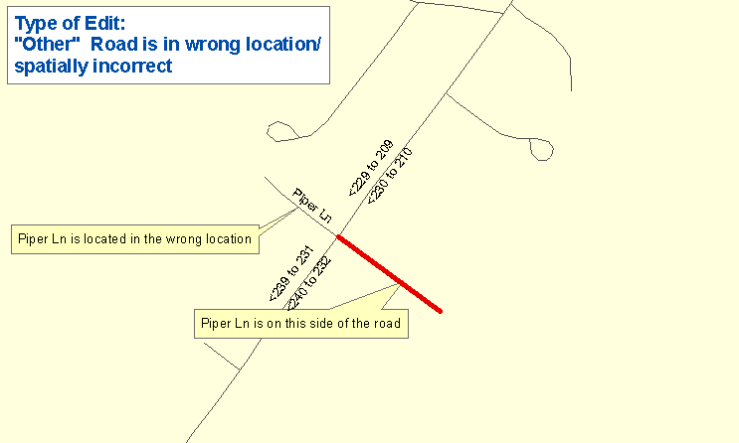

One Maine Enhanced 9-1-1 Update Form will need to be filled out for the above edit. The following sections are found on MSAG Update Forms and serves as an example as to what information needs to be provided to Emergency Services Communications Bureau/GIS in order to complete the edit. In addition, please provide all the information noted on the map above by marking it on a copy of the map book page. Please submit both the map book page and the Update Form to Emergency Services Communications Bureau/GIS.

FORM 1

Remarks: Piper Ln is on the wrong side of the road. All the data pertaining to this road is still correct (i.e. road name and address range data). The address ranges before and after the intersection with Piper Ln with Main Street are still the same.

